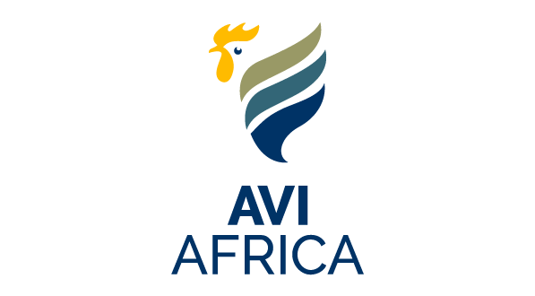
SAPA MEMBERS
25% DISCOUNT

EMPERORS PALACE, GAUTENG: 6-8 June 2023

TICK CLEARLY

6 June
7 June
8 June

LUNCH PACKAGE Includes Conference, Exhibition, Tea/Coffee, Lunch & Cocktail functions  3 Day Package = R1 590 (VAT incl)  3 days  2 Day Package = R1 060 (VAT incl)  2 days  1 Day Package = R530 (VAT incl)  1 day | NO LUNCH PACKAGE Includes Conference, Exhibition, Tea/Coffee & Cocktail function  3 days  3 Day Package = R1 080 (VAT incl)  2 days  2 Day Package = R720 (VAT incl)  1 day  1 Day Package = R360 (VAT incl)
Details of delegate, e-mail back to aviafrica@sapoultry.co.za (Please complete all fields)

ORDER NO: VAT NO:
Company:
Postal Address:
CODE:
Country:
Delegate Name & Surname:
Telephone/Cell no: Fax:
E-mail:

PLEASE TICK WHERE APPLICABLE:

Broiler Organisation Egg Organisation Allied Member Contract grower

Cancellation policy: R250 admin fee will be charged for all cancellations received after 15 May 2023 and no refunds will be made for cancellations thereafter or for non-attendance.
RETURN COMPLETED FORM TO:
S A Poultry Association, P O Box 1202, Honeydew, 2040
E-mail: aviafrica@sapoultry.co.za

BANK DETAILS:
SA Poultry Association
ABSA Bank Northcliff
Account number: 730 720 238
Branch code: 334 705
Please send proof of payment

WELCOME TO AVI AFRICA 2023
PLEASE NOTE
This ticket allows you entrance to the exhibition and/or conference, social function and lunch, depending on the category. Please wear your nametag at all times. Daily lunch ticketholders must hand in their lunch ticket during lunch at the restaurant on the1st floor. Exhibitors may have lunch during the first session. Unfortunately, NO DUPLICATE entrance and lunch tickets will be available.
In the event of any enquiries, please go to the SAPA registration desk. A business center is also available at the SAPA registration desk.
Right of admission reserved.

Signature: Position: Date:

Accommodation for your own account

